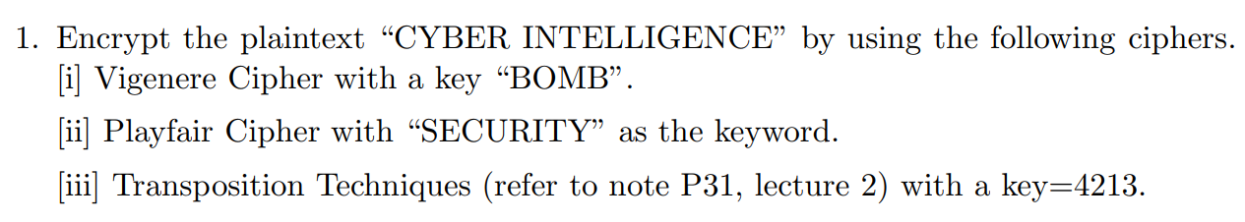

|  |  |  |  |  |  |  |  |  |  |  |  |  |  |  |  |  |  |  |  |  |  |  |  |  |  |
| --- | --- | --- | --- | --- | --- | --- | --- | --- | --- | --- | --- | --- | --- | --- | --- | --- | --- | --- | --- | --- | --- | --- | --- | --- | --- |
| 0 | 1 | 2 | 3 | 4 | 5 | 6 | 7 | 8 | 9 | 10 | 11 | 12 | 13 | 14 | 15 | 16 | 17 | 18 | 19 | 20 | 21 | 22 | 23 | 24 | 25 |
| **A** | **B** | **C** | **D** | **E** | **F** | **G** | **H** | **I** | **J** | **K** | **L** | **M** | **N** | **O** | **P** | **Q** | **R** | **S** | **T** | **U** | **V** | **W** | **X** | **Y** | **Z** |

1. **BOMBBOMBBOMBBOMBB**  
   **CYBERINTELLIGENCE**1 + 2 mod 26 = D

14 + 24 mod 26 = M  
12 + 1 mod 26 = N  
1 + 4 mod 26 = F  
1 + 17 mod 26 = S  
14 + 8 mod 26 = W  
12 + 13 mod 26 = Z  
1 + 19 mod 26 = U  
1 + 4 mod 26 = F  
14 + 11 mod 26 = Z  
12 + 11 mod 26 = X  
1 + 8 mod 26 = J  
1 + 6 mod 26 = H  
14 + 4 mod 26 = S  
12 + 13 mod 26 = Z  
1 + 2 mod 26 = D  
1 + 4 mod 26 = F

1. S E C U R  
   I T Y A B  
   D F G H K  
   L M N O P  
   Q V W X Z  
     
   **CYBERINTELLIGENCE**CY BE RI NT EL LI GE NC EZ  
   YG TR SB MY SM QD FC WY RV
2.   
     
   Transposition  
     
   4 2 1 3  
   C Y B E  
   R I N T  
   E L L I   
   G E N C  
   E X Y Z  
     
   1 2 3 4  
   B Y E C  
   N I T R  
   L L I E  
   N E C G  
   Y X Z E  
     
   **CIPHER-TEXT**: BNLNYYILEXETICZCREGE  
     
     
     
     
   3 5

2 9  
  
14  
25  
  
3x14 + 5x25 = 167  
2x14 + 9x25 = 253  
  
167 mod 26 = 11  
253 mod 26 = 19  
  
**Answer:** LT

  
  
  
  
101010011011  
011000001100  
110010010111  
  
**Answer:** 011000001100